TARGETING THE HEART UTILIZING A NOVEL CELL PENETRATING PEPTIDE
M. Zahid
Dept. of Developmental Biology, University of Pittsburgh, Pittsburgh, PA, USA

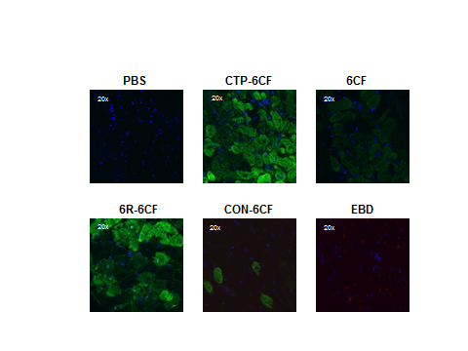
A major challenge to the development of cardiac therapeutics is the delivery of agents selectively to cardiac myocytes with little or no penetrance into other cell types. Plasmid based delivery suffers from low efficiency and requires direct injection in the myocardium; viral vectors have the draw-back of pre-existing immunity or rapid development of immunity upon exposure and low efficiencies. Cell penetrating peptides (CPP) are small 6-30 amino acid peptides able to carry cargo ranging from small peptides, to proteins, DNA, siRNA, radio-isotopes, viral particles and nanoparticles across the cellular membranes resulting in internalization of the intact cargo. Our prior work utilizing a combinatorial in vitro and in vivo approach of phage display led to the identification of a 12-amino acid peptide, APWHLSSQYSRT, which we termed Cardiac Targeting Peptide (CTP), because of its ability to transduce the mouse heart tissue efficiently in vivo after an intravenous injection. Following injection, 6-carboxyfluorescein (6-CF) labeled CTP was internalized throughout normal mouse heart-tissue, as shown by co-localization of the peptide with the cytoplasmic markers actin and exclusion from laminin, a plasma membrane marker, in confocal images. Additionally, a time-course experiment using CTP labeled with a substantially larger fluorescent marker, streptavidin-AF488 (SA488) injected intravenously showed robust cardiac uptake at 30 mins without significant uptake by lungs, brain, gut, liver, spleen, adipose tissue or skeletal muscle. Some fluorescence was seen in kidney tissue at later time points, likely reflecting excretion of the peptide or the fluorescent marker. Biotinylated CTP conjugated with neutravidin-labeled fluospheres localized to the heart as determined by in vivo whole mouse live imaging. In contrast, fluospheres alone and a scrambled control peptide conjugated to fluospheres failed to localize to the heart, with the fluorescence immediately dissipating throughout the mouse body. Incubating human explanted heart tissue from patients undergoing heart transplant with CTP labeled with 6-CF showed robust transduction of cardiomyocytes, with sparing of fibrous scar tissue. The peptide localized to the cytoplasm with punctate appearance, suggesting localization to vesicular compartments without any fluorescence seen in the nucleus. This robust transduction of explanted human heart was not due to a simple increase in plasma membrane permeability, as evidenced by lack of uptake of Evans Blue dye. A scrambled control peptide and 6-CF alone showed none to minimal uptake, while 6-Arginine, a known non-tissue specific CPP showed robust cardiac uptake as well.
Hence we have identified a novel CPP that is able to target the murine heart specifically and efficiently and has the ability to carry relatively large cargo. Further studies are warranted to understand it’s mechanism of transduction as well as study its utility as a cardiac targeting agent.

